**Assessment Title: Heart Disease Prediction Using Machine Learning — Analysis Report**

**Use Google Doc**

# **Task 1: Research review**

In this task, you are required to provide a comprehensive understanding on the analysis of Heart Disease Prediction using Machine Learning. Your report should cover various aspects, including research on proposed models and techniques.

# Introduction

1. Briefly introduce the concept and problem statement.

# Literature Review

1. Conduct a review of relevant literature on the given topic, focusing on key theories, models, and findings. You can use Research Papers to explore the area and cite them properly.
2. Identify common factors influencing the disease.

# References

1. Cite relevant sources for the dataset, machine learning algorithms, industry benchmarks, and literature review.
2. Follow the **Harvard citation style** consistently throughout the report.

**Word limit:** Word limit for task 1 is 1000 - 1500 words

# **Task 2: Data Exploration Analysis**

In this task, you are required to provide the insights you can draw from the given set of plots. Explain each figure and show the understanding of the pattern with respect to attributes. Show the brief analysis in bullet points and paragraphs. Include statistical values to support your analysis.

**Figure 1: Chances of Heart Disease With respect to Gender**

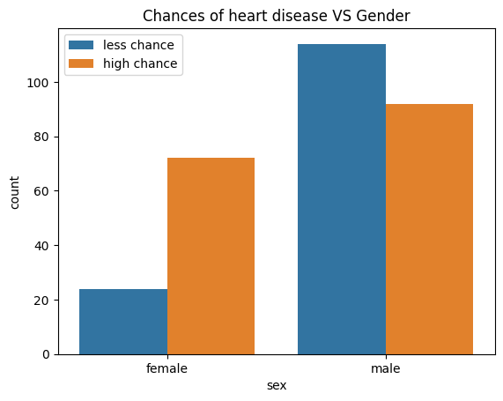

[Write down your Analysis here-100-200 words including bullet points]

**Figure 2: Patients with Fasting Blood Sugar(FBS) related to heart attack**

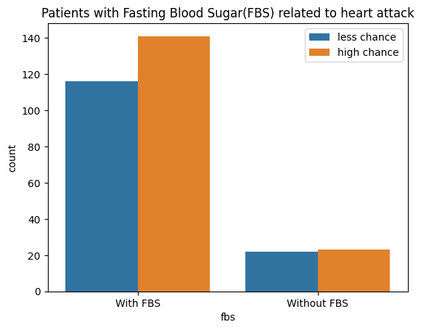

[Write down your Analysis here-100-200 words including bullet points]

**Submission Guidelines**

1. Submit a well-structured document in **PDF** format.
2. Include visualizations, tables, or graphs to support your analysis, with proper captions and numbers.
3. Add **5-10** References with desired Format, for task 1.

**Submission Deadline:** Submit the report in PDF format by 04-February-2024 (4:00 pm IST)

**Submit your Solution at** [**helperminds4u@gmail.com**](mailto:helperminds4u@gmail.com) **with subject as “Assessment(Data Science Content Writer)-Solution”**

**Note:** The assessment will be carefully examined therefore prevent using ChatGPT or any AI tool for content generation. The plagiarism should be avoided as this could strictly violate the assessment rule and can lead to elimination. Content should have statistical information as well, not just general theory.

**Best of luck with your analysis!**